CHAPTER 11
Photosynthesis in Higher Plants
• Photosynthesis in Higher Plants

Unit 4 | PLANT PHYSIOLOGY - Unit Introduction

The description of the structure and variation of living organisms over a period of time ended up as two apparently irreconcilable perspectives on biology. The two rest on two levels of organisation of life forms and phenomena.
Perspective | Level of organisation described | Disciplines it resulted in
First | Life at the organismic and above level | Ecology and related disciplines
Second | Life at the cellular and molecular level | Physiology and biochemistry

In this unit the processes of photosynthesis, respiration and plant growth and development are described in molecular terms, but in the context of cellular activities and even at organism level. The relation of the physiological processes to environment is also discussed.
Profile | MELVIN CALVIN (1911-1997)

• Melvin Calvin was born in Minnesota in April 1911. He received his Ph.D. in Chemistry from the University of Minnesota and served as Professor of Chemistry at the University of California, Berkeley.
• Just after world war II, when the world was under shock after the Hiroshima-Nagasaki bombings and seeing the ill-effects of radio-activity, Calvin and co-workers put radio-activity to beneficial use.
• Calvin, along with J.A. Bassham, studied reactions in green plants forming sugar and other substances from raw materials like carbon dioxide, water and minerals, by labelling the carbon dioxide with C¹⁴.
• Calvin proposed that plants change light energy to chemical energy by transferring an electron in an organised array of pigment molecules and other substances.
• The mapping of the pathway of carbon assimilation in photosynthesis earned Melvin Calvin the Nobel Prize in 1961.
• The principles of photosynthesis as established by Calvin are at present being used in studies on renewable resource for energy and materials and basic studies in solar energy research.
Ch 11 | PHOTOSYNTHESIS IN HIGHER PLANTS

All animals including human beings depend on plants for their food.
• Autotrophs - green plants make, or rather synthesise, the food they need through photosynthesis, and are therefore called autotrophs. Autotrophic nutrition is found only in plants; all other organisms that depend on the green plants for food are heterotrophs.
• Photosynthesis - a physico-chemical process by which green plants use light energy to drive the synthesis of organic compounds.
Ultimately, all living forms on earth depend on sunlight for energy. The use of energy from sunlight by plants doing photosynthesis is the basis of life on earth.
Photosynthesis is important due to two reasons:
• It is the primary source of all food on earth.
• It is also responsible for the release of oxygen into the atmosphere by green plants.
This chapter focusses on the structure of the photosynthetic machinery and the various reactions that transform light energy into chemical energy.
11.1 | WHAT DO WE KNOW?

Simple experiments have shown that chlorophyll (green pigment of the leaf), light and CO₂ are required for photosynthesis to occur.
During photosynthesis carbon dioxide from the atmosphere is taken in by leaves through stomata and used for making carbohydrates, principally glucose and starch.
Experiment 1 - is chlorophyll and light needed?
1 | Two leaves are used: a variegated leaf, or a leaf that was partially covered with black paper.
2 | Both are exposed to light.
3 | The leaves are then tested for the presence of starch.
4 | Result: photosynthesis occurred only in the green parts of the leaves in the presence of light.

Experiment 2 - is CO₂ needed?
1 | A part of a leaf is enclosed in a test tube containing some KOH soaked cotton, which absorbs CO₂.
2 | The other half is exposed to air.
3 | The setup is placed in light for some time, then tested for starch.
4 | Result: the exposed part tested positive for starch, while the portion inside the tube tested negative - showing that CO₂ was required for photosynthesis.

11.2 | EARLY EXPERIMENTS

It is interesting to learn about those simple experiments that led to a gradual development in our understanding of photosynthesis.
11.2a | Joseph Priestley (1733-1804)

• In 1770 Joseph Priestley performed a series of experiments that revealed the essential role of air in the growth of green plants. Priestley discovered oxygen in 1774.
1 | Priestley observed that a candle burning in a closed space - a bell jar - soon gets extinguished.
2 | Similarly, a mouse would soon suffocate in a closed space.
3 | He concluded that a burning candle or an animal that breathe the air both somehow damage the air.
4 | When he placed a mint plant in the same bell jar, the mouse stayed alive and the candle continued to burn.

[NOTE] Priestley's hypothesis: Plants restore to the air whatever breathing animals and burning candles remove.

11.2b | Jan Ingenhousz (1730-1799)

• Using a similar setup as the one used by Priestley, but by placing it once in the dark and once in the sunlight, Ingenhousz showed that sunlight is essential to the plant process that somehow purifies the air fouled by burning candles or breathing animals.
• In an elegant experiment with an aquatic plant he showed that in bright sunlight small bubbles were formed around the green parts, while in the dark they did not. He later identified these bubbles to be of oxygen. He hence showed that it is only the green part of the plants that could release oxygen.
11.2c | Julius von Sachs (evidence of 1854)

• It was not until about 1854 that Julius von Sachs provided evidence for the production of glucose when plants grow. Glucose is usually stored as starch. Sachs found that the green parts in plants is where glucose is made, and that the glucose is usually stored as starch.
• His later studies showed that the green substance in plants (chlorophyll as we know it now) is located in special bodies (later called chloroplasts) within plant cells.
11.2d | T.W Engelmann (1843-1909)

1 | Using a prism, Engelmann split light into its spectral components.
2 | He then illuminated a green alga, Cladophora, placed in a suspension of aerobic bacteria.
3 | The bacteria were used to detect the sites of O₂ evolution.
4 | The bacteria accumulated mainly in the region of blue and red light of the split spectrum.
5 | A first action spectrum of photosynthesis was thus described; it resembles roughly the absorption spectra of chlorophyll a and b.

11.2e | The First Empirical Equation

• By the middle of the nineteenth century the key features of plant photosynthesis were known, namely that plants could use light energy to make carbohydrates from CO₂ and water.
• The empirical equation representing the total process of photosynthesis for oxygen evolving organisms was then understood as: CO₂ + H₂O, in the presence of light, yields [CH₂O] + O₂. Here [CH₂O] represented a carbohydrate (e.g., glucose, a six-carbon sugar).
11.2f | Cornelius van Niel (1897-1985)

• A milestone contribution to the understanding of photosynthesis was made by a microbiologist, Cornelius van Niel. Based on his studies of purple and green bacteria, he demonstrated that photosynthesis is essentially a light-dependent reaction in which hydrogen from a suitable oxidisable compound reduces carbon dioxide to carbohydrates.
• His finding can be expressed by: 2H₂A + CO₂, in the presence of light, yields 2A + CH₂O + H₂O.
• In green plants H₂O is the hydrogen donor and is oxidised to O₂. Some organisms do not release O₂ during photosynthesis: when H₂S instead is the hydrogen donor for purple and green sulphur bacteria, the 'oxidation' product is sulphur or sulphate depending on the organism, and not O₂.
• Van Niel hence inferred that the O₂ evolved by the green plant comes from H₂O, not from carbon dioxide. This was later proved by using radioisotopic techniques - the O₂ released is from water.
• The correct equation that would represent the overall process of photosynthesis is: 6CO₂ + 12H₂O, in the presence of light, yields C₆H₁₂O₆ + 6H₂O + 6O₂, where C₆H₁₂O₆ represents glucose. This is not a single reaction but a description of a multistep process called photosynthesis.
11.3 | WHERE DOES PHOTOSYNTHESIS TAKE PLACE?

You would of course answer: in 'the green leaf' or 'in the chloroplasts', based on what you earlier read in Chapter 8.
• Photosynthesis does take place in the green leaves of plants, but it does so also in other green parts of the plants.
• The mesophyll cells in the leaves have a large number of chloroplasts. Usually the chloroplasts align themselves along the walls of the mesophyll cells, such that they get the optimum quantity of the incident light.
• Photosynthesis has two stages: the light reaction and the carbon fixing reactions.
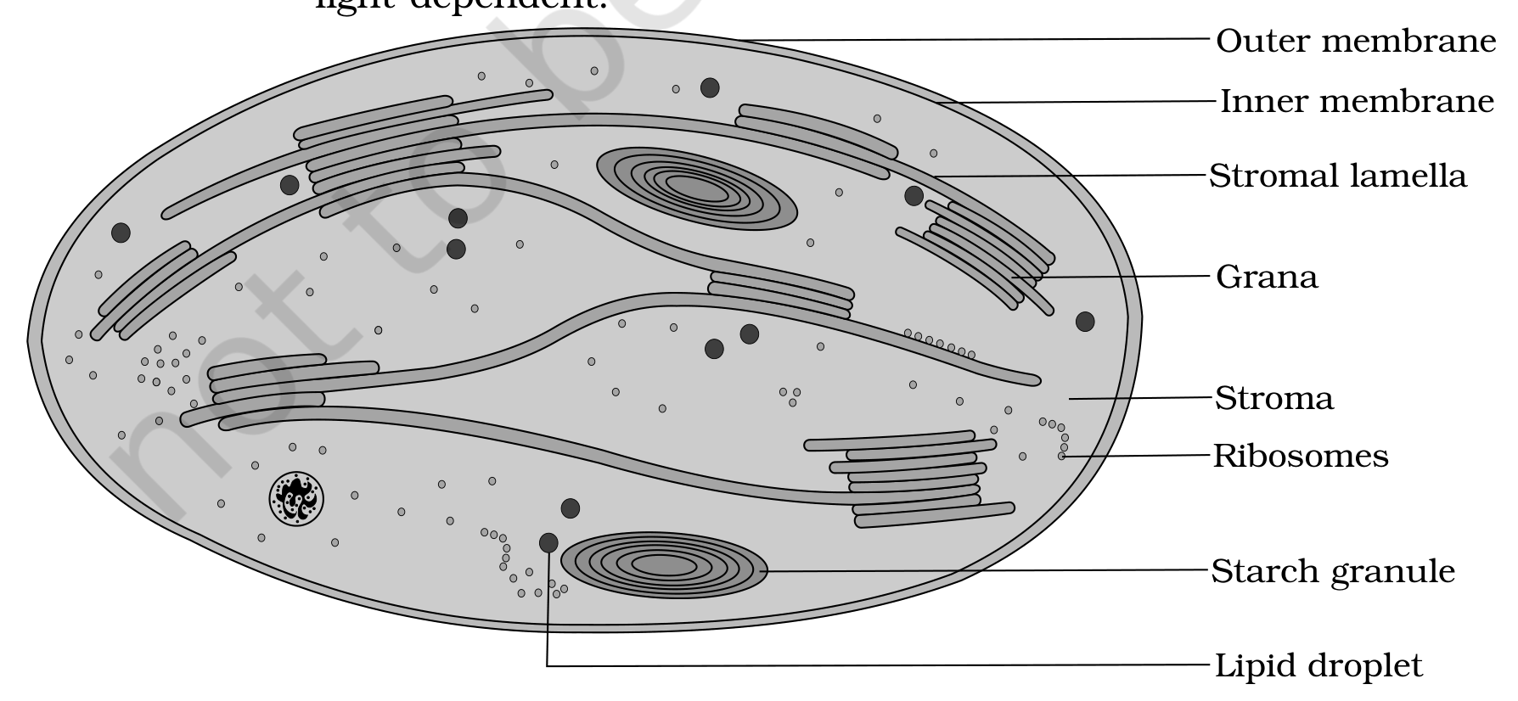
Fig. 11.2 - Diagrammatic representation of an electron micrograph of a section of chloroplast.
Within the chloroplast there is a membranous system consisting of the grana, the stroma lamellae, and the matrix stroma. The parts marked on the section of the chloroplast are:
Part of the chloroplast | What it is
Outer membrane | The outer of the two bounding membranes of the chloroplast
Inner membrane | The inner bounding membrane, lying within the outer membrane
Grana | The stacked membrane compartments of the membranous system
Stromal lamella | The membrane lamellae connecting the grana; also written stroma lamellae
Stroma | The matrix in which the grana and stromal lamella are embedded
Ribosomes | Present in the stroma of the chloroplast
Starch granule | Stored product lying in the stroma
Lipid droplet | Lipid body lying in the stroma

There is a clear division of labour within the chloroplast:
• The membrane system is responsible for trapping the light energy and also for the synthesis of ATP and NADPH.
• In stroma, enzymatic reactions synthesise sugar, which in turn forms starch.
• Within the chloroplasts the membranes are sites for the light reaction, while the chemosynthetic pathway occurs in the stroma.
• Light reactions (photochemical reactions) - the reactions of the membrane system, since they are directly light driven.
• Dark reactions (carbon reactions) - the stromal reactions. They are not directly light driven but are dependent on the products of light reactions (ATP and NADPH); hence, to distinguish them, they are called dark reactions by convention.
[NOTE] That the stromal reactions are called dark reactions should not be construed to mean that they occur in darkness or that they are not light-dependent.

11.4 | HOW MANY TYPES OF PIGMENTS ARE INVOLVED IN PHOTOSYNTHESIS?

Looking at plants have you ever wondered why and how there are so many shades of green in their leaves - even in the same plant?
• The leaf pigments of any green plant can be separated through paper chromatography. A chromatographic separation shows that the colour that we see in leaves is not due to a single pigment but due to four pigments.
Leaf pigment | Colour in the chromatogram
Chlorophyll a | Bright or blue green
Chlorophyll b | Yellow green
Xanthophylls | Yellow
Carotenoids | Yellow to yellow-orange

• Pigments - substances that have an ability to absorb light at specific wavelengths.
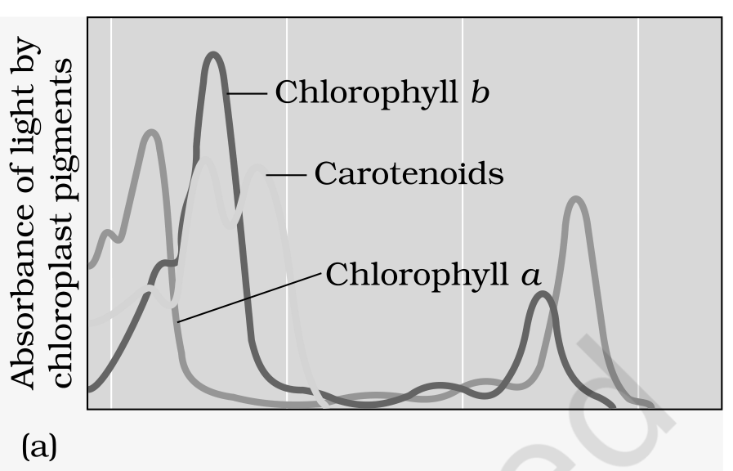 | 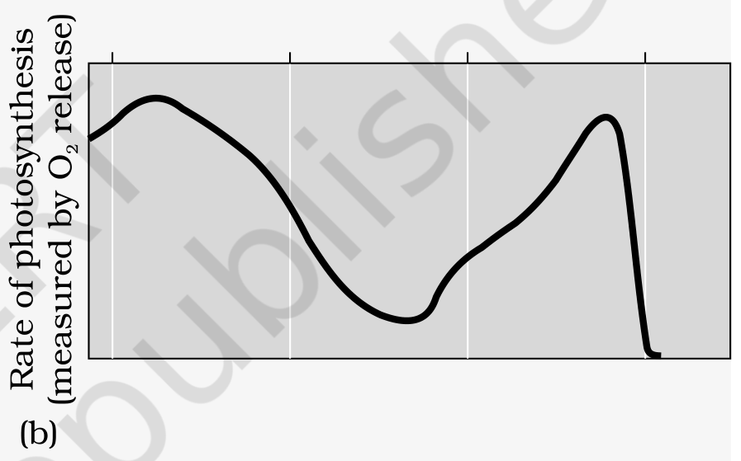

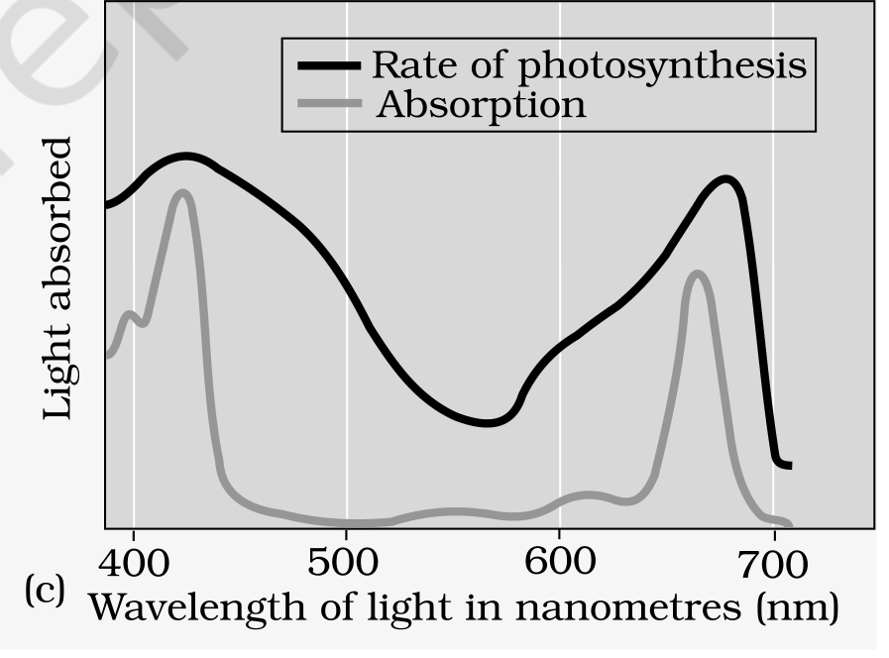
Fig. 11.3c - Graph showing the action spectrum of photosynthesis superimposed on the absorption spectrum of chlorophyll a. The original separated the two curves by colour: the Rate of photosynthesis curve was black and the Absorption curve was cyan, and the shaded band is Light absorbed. Its horizontal axis is Wavelength of light in nanometres (nm), marked at 400, 500, 600 and 700. Panel marker: (c).
• The wavelengths at which there is maximum absorption by chlorophyll a, i.e., in the blue and the red regions, also show a higher rate of photosynthesis. Hence we can conclude that chlorophyll a is the chief pigment associated with photosynthesis.
• There is not a complete one-to-one overlap between the absorption spectrum of chlorophyll a and the action spectrum of photosynthesis. The graphs together show that most of the photosynthesis takes place in the blue and red regions of the spectrum; some photosynthesis does take place at the other wavelengths of the visible spectrum.
• Accessory pigments - though chlorophyll is the major pigment responsible for trapping light, other thylakoid pigments like chlorophyll b, xanthophylls and carotenoids are called accessory pigments. They also absorb light and transfer the energy to chlorophyll a.
• The accessory pigments not only enable a wider range of wavelength of incoming light to be utilised for photosynthesis, but also protect chlorophyll a from photo-oxidation.
11.5 | WHAT IS LIGHT REACTION?

• Light reactions or the 'Photochemical' phase include light absorption, water splitting, oxygen release, and the formation of high-energy chemical intermediates, ATP and NADPH.
• Several protein complexes are involved in the light reaction. The pigments are organised into two discrete photochemical light harvesting complexes (LHC) within Photosystem I (PS I) and Photosystem II (PS II).
[NOTE] The photosystems are named in the sequence of their discovery, and not in the sequence in which they function during the light reaction.

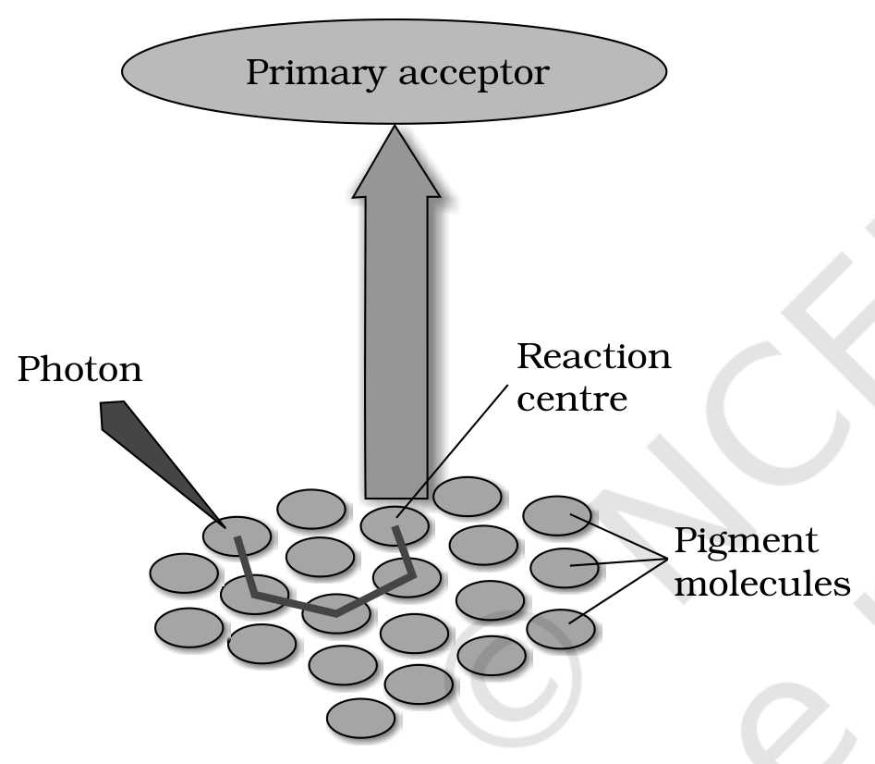
Fig. 11.4 - The light harvesting complex.
The parts marked on the light harvesting complex are the Pigment molecules, the Reaction centre, the Primary acceptor, and the incoming Photon of light.
• The LHC are made up of hundreds of pigment molecules bound to proteins.
• Each photosystem has all the pigments (except one molecule of chlorophyll a) forming a light harvesting system, also called antennae. These antenna pigments help to make photosynthesis more efficient by absorbing different wavelengths of light.
• The single chlorophyll a molecule forms the reaction centre, and the reaction centre is different in both the photosystems.
• In the light reaction the light energy is absorbed by the pigments present in the antenna and funnelled to special chlorophyll a molecules called reaction centre chlorophylls.
Photosystem | Reaction centre chlorophyll a | Absorption peak | Called
PS I | One chlorophyll a molecule | 700 nm | P700
PS II | One chlorophyll a molecule | 680 nm | P680

11.6 | THE ELECTRON TRANSPORT

1 | In photosystem II the reaction centre chlorophyll a absorbs 680 nm wavelength of red light, causing electrons to become excited and jump into an orbit farther from the atomic nucleus.
2 | These electrons are picked up by an electron acceptor, which passes them to an electron transport system consisting of cytochromes.
3 | This movement of electrons is downhill, in terms of an oxidation-reduction or redox potential scale. The electrons are not used up as they pass through the electron transport chain, but are passed on to the pigments of photosystem PS I.
4 | Simultaneously, electrons in the reaction centre of PS I are also excited when they receive red light of wavelength 700 nm, and are transferred to another accepter molecule that has a greater redox potential.
5 | These electrons then are moved downhill again, this time to a molecule of energy-rich NADP⁺. The addition of these electrons reduces NADP⁺ to NADPH + H⁺.

• Z scheme - the whole scheme of transfer of electrons, starting from PS II, uphill to the acceptor, down the electron transport chain to PS I, excitation of electrons, transfer to another acceptor, and finally downhill to NADP⁺ reducing it to NADPH + H⁺. It is so called due to its characterstic shape, which is formed when all the carriers are placed in a sequence on a redox potential scale.
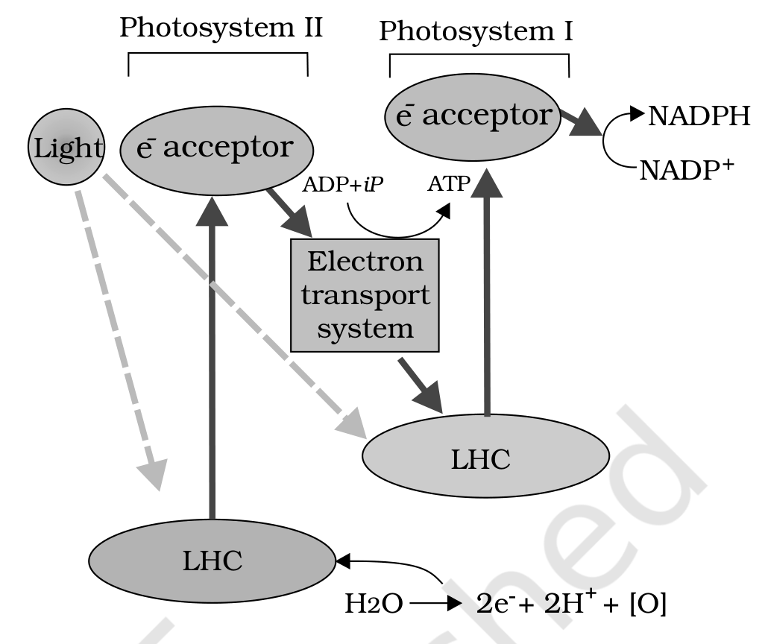
Fig. 11.5 - Z scheme of light reaction.
The Z scheme diagram is marked with Photosystem II and Photosystem I, each receiving Light through its LHC; the e acceptor above each photosystem; the Electron transport system joining them; ADP + iP being converted to ATP; NADP⁺ being reduced to NADPH; and, at PS II, H₂O being split to give 2e⁻ + 2H⁺ + [O].
11.6.1 | Splitting of Water

You would then ask, How does PS II supply electrons continuously?
• The electrons that were moved from photosystem II must be replaced, and this is achieved by electrons available due to splitting of water.
• The splitting of water is associated with the PS II; water is split into 2H⁺, [O] and electrons. This creates oxygen, one of the net products of photosynthesis.
• The electrons needed to replace those removed from photosystem I are provided by photosystem II.
• The water-splitting reaction is: 2H₂O yields 4H⁺ + O₂ + 4e⁻.
[NOTE] The water splitting complex is associated with the PS II, which itself is physically located on the inner side of the membrane of the thylakoid.

11.6.2 | Cyclic and Non-cyclic Photo-phosphorylation

Living organisms have the capability of extracting energy from oxidisable substances and store this in the form of bond energy. Special substances like ATP carry this energy in their chemical bonds.
• Phosphorylation - the process through which ATP is synthesised by cells (in mitochondria and chloroplasts).
• Photophosphorylation - the synthesis of ATP from ADP and inorganic phosphate in the presence of light.
• Non-cyclic photo-phosphorylation - occurs when the two photosystems work in a series, first PS II and then the PS I. The two photosystems are connected through an electron transport chain, as seen in the Z scheme, and both ATP and NADPH + H⁺ are synthesised by this kind of electron flow.
• When only PS I is functional, the electron is circulated within the photosystem and the phosphorylation occurs due to cyclic flow of electrons. A possible location where cyclic photophosphorylation could be happening is in the stroma lamellae.
• While the membrane or lamellae of the grana have both PS I and PS II, the stroma lamellae membranes lack PS II as well as NADP reductase enzyme.
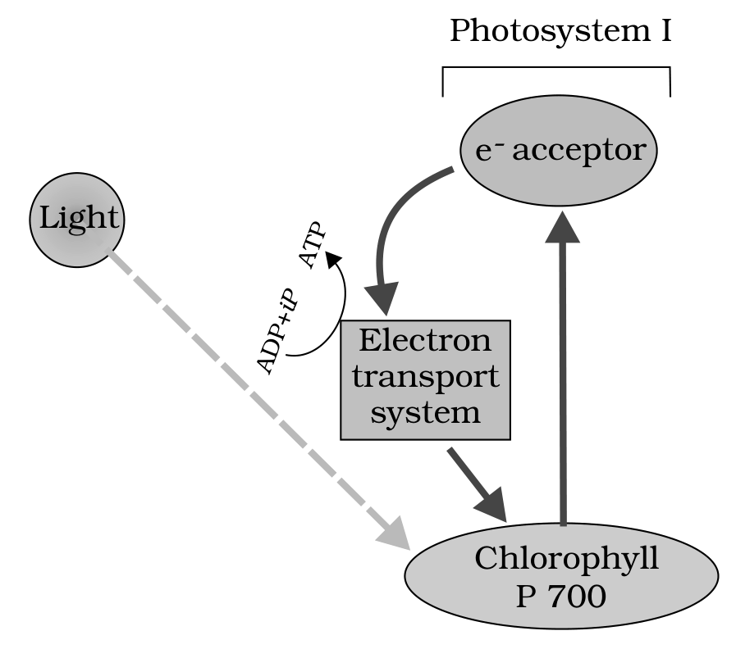
Fig. 11.6 - Cyclic photophosphorylation.
The cyclic photophosphorylation diagram is marked with Photosystem I alone, its incoming Light, its Chlorophyll P 700 reaction centre, the e- acceptor above it, the Electron transport system returning the electron to the same photosystem, and ADP + iP being converted to ATP.
• In cyclic flow the excited electron does not pass on to NADP⁺ but is cycled back to the PS I complex through the electron transport chain. The cyclic flow hence results only in the synthesis of ATP, but not of NADPH + H⁺.
• Cyclic photophosphorylation also occurs when only light of wavelengths beyond 680 nm are available for excitation.
11.6.3 | Chemiosmotic Hypothesis

Let us now try and understand how actually ATP is synthesised in the chloroplast. The chemiosmotic hypothesis has been put forward to explain the mechanism by which ATP is synthesised in the chloroplast.
• Like in respiration, in photosynthesis too ATP synthesis is linked to development of a proton gradient across a membrane; this time these are the membranes of thylakoid.
• There is one difference though: here the proton accumulation is towards the inside of the membrane, i.e., in the lumen, whereas in respiration protons accumulate in the intermembrane space of the mitochondria when electrons move through the ETS.
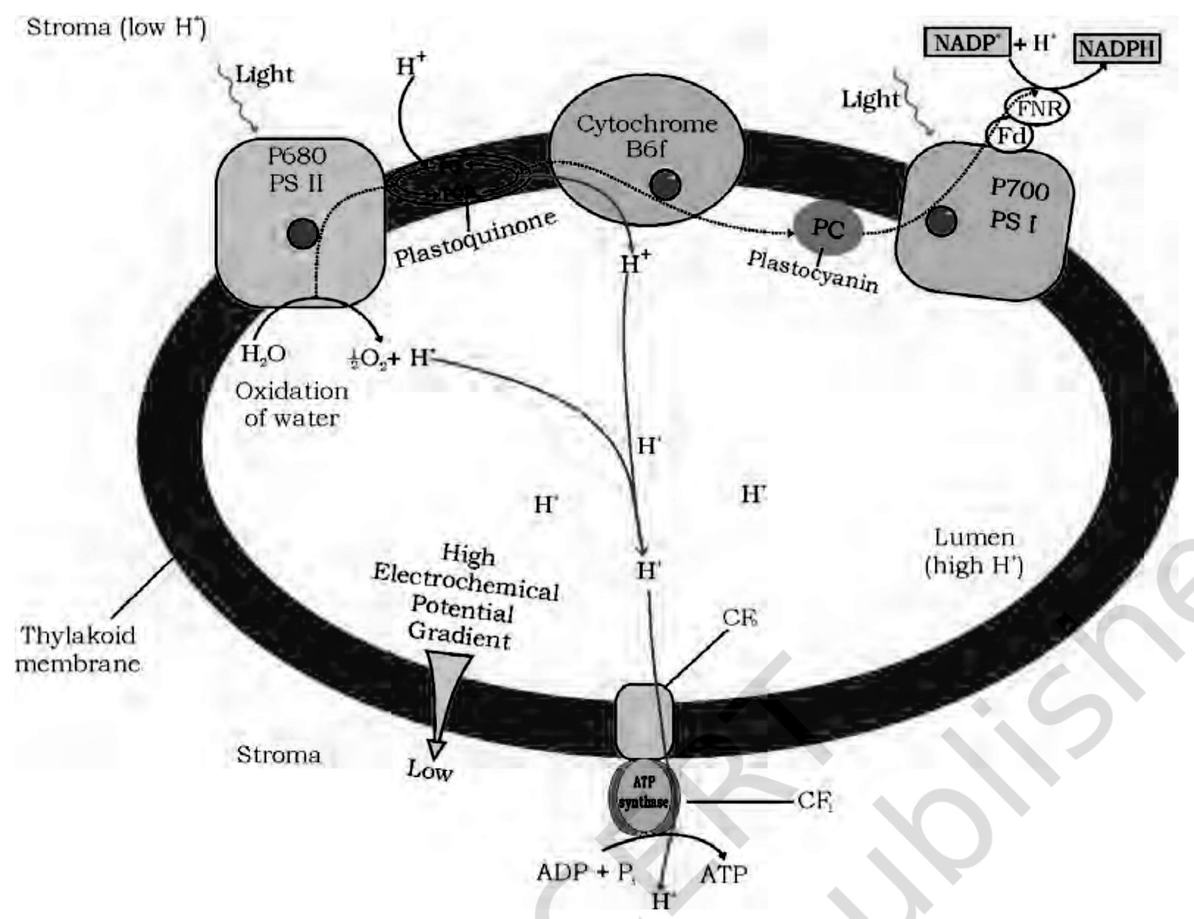
Fig. 11.7 - ATP synthesis through chemiosmosis.
The chemiosmosis diagram is drawn across the Thylakoid membrane, with the Stroma (low H⁺) on the outer side and the Lumen (high H⁺) on the inner side. Along the membrane, in order, it is marked: incoming Light at P680 PS II, then Plastoquinone, Cytochrome B6f, PC (Plastocyanin), then Light again at P700 PS I, then Fd and FNR, which reduces NADP⁺ + H⁺ to NADPH. On the lumen side the Oxidation of water splits H₂O into 1/2 O₂ + H⁺, releasing H⁺ into the lumen.
The vertical scale beside the membrane runs from High Electrochemical Potential Gradient down to Low, from the Lumen to the Stroma. At the right the ATP synthase is drawn in its two parts, CF₀ in the membrane and CF₁ facing the stroma, converting ADP + Pi into ATP.
1 | Since splitting of the water molecule takes place on the inner side of the membrane, the protons or hydrogen ions that are produced by the splitting of water accumulate within the lumen of the thylakoids.
2 | As electrons move through the photosystems, protons are transported across the membrane, because the primary accepter of electron, which is located towards the outer side of the membrane, transfers its electron not to an electron carrier but to an H carrier.
3 | Hence this H-carrier molecule removes a proton from the stroma while transporting an electron; when this molecule passes on its electron to the electron carrier on the inner side of the membrane, the proton is released into the inner side or the lumen side of the membrane.
4 | The NADP reductase enzyme is located on the stroma side of the membrane. Along with electrons that come from the acceptor of electrons of PS I, protons are necessary for the reduction of NADP⁺ to NADPH + H⁺; these protons are also removed from the stroma.
5 | Hence, within the chloroplast, protons in the stroma decrease in number, while in the lumen there is accumulation of protons. This creates a proton gradient across the thylakoid membrane as well as a measurable decrease in pH in the lumen.

• The proton gradient is important because it is the breakdown of this gradient that leads to the synthesis of ATP. The gradient is broken down due to the movement of protons across the membrane to the stroma through the transmembrane channel of the CF₀ of the ATP synthase.
• ATP synthase - the enzyme consists of two parts. One, called CF₀, is embedded in the thylakoid membrane and forms a transmembrane channel that carries out facilitated diffusion of protons across the membrane. The other portion is called CF₁ and protrudes on the outer surface of the thylakoid membrane on the side that faces the stroma.
• The breakdown of the gradient provides enough energy to cause a conformational change in the CF₁ particle of the ATP synthase, which makes the enzyme synthesise several molecules of energy-packed ATP.
Chemiosmosis requires:
- a membrane;
- a proton pump;
- a proton gradient;
- ATP synthase.
Energy is used to pump protons across a membrane, to create a gradient or a high concentration of protons within the thylakoid lumen. ATP synthase has a channel that allows diffusion of protons back across the membrane, and this releases enough energy to activate ATP synthase enzyme that catalyses the formation of ATP.
• Along with the NADPH produced by the movement of electrons, the ATP will be used immediately in the biosynthetic reaction taking place in the stroma, responsible for fixing CO₂ and synthesis of sugars.
11.7 | WHERE ARE THE ATP AND NADPH USED?

• The products of light reaction are ATP, NADPH and O₂. Of these, O₂ diffuses out of the chloroplast, while ATP and NADPH are used to drive the processes leading to the synthesis of food, more accurately sugars.
• Biosynthetic phase of photosynthesis - the synthesis of sugars using ATP and NADPH.
• The biosynthetic process does not directly depend on the presence of light but is dependent on the products of the light reaction, i.e., ATP and NADPH, besides CO₂ and H₂O.
• Immediately after light becomes unavailable the biosynthetic process continues for some time and then stops. If then light is made available, the synthesis starts again.
• CO₂ is combined with H₂O to produce (CH₂O)n or sugars. The use of radioactive ¹⁴C by Melvin Calvin in algal photosynthesis studies led to the discovery that the first CO₂ fixation product was a 3-carbon organic acid. Calvin also contributed to working out the complete biosynthetic pathway; hence it was called the Calvin cycle after him. The first product identified was 3-phosphoglyceric acid, or in short PGA.
• Experiments conducted over a wide range of plants led to the discovery of another group of plants where the first stable product of CO₂ fixation was again an organic acid, but one which had 4 carbon atoms in it. This acid was identified to be oxaloacetic acid or OAA.
Type of CO₂ assimilation | First product of CO₂ fixation | Pathway
Plants whose first product is a C₃ acid | PGA | the C₃ pathway
Plants whose first product is a C₄ acid | OAA | the C₄ pathway

11.7.1 | The Primary Acceptor of CO₂

Let us now ask ourselves a question that was asked by the scientists who were struggling to understand the 'dark reaction'.
• Scientists believed that since the first product was a C₃ acid, the primary acceptor would be a 2-carbon compound. They spent many years trying to identify a 2-carbon compound before they discovered the 5-carbon RuBP.
• The studies very unexpectedly showed that the acceptor molecule was a 5-carbon ketose sugar - ribulose bisphosphate (RuBP).
11.7.2 | The Calvin Cycle

• Calvin and his co-workers then worked out the whole pathway and showed that the pathway operated in a cyclic manner; the RuBP was regenerated.
[NOTE] The Calvin pathway occurs in all photosynthetic plants; it does not matter whether they have C₃ or C₄ (or any other) pathways.

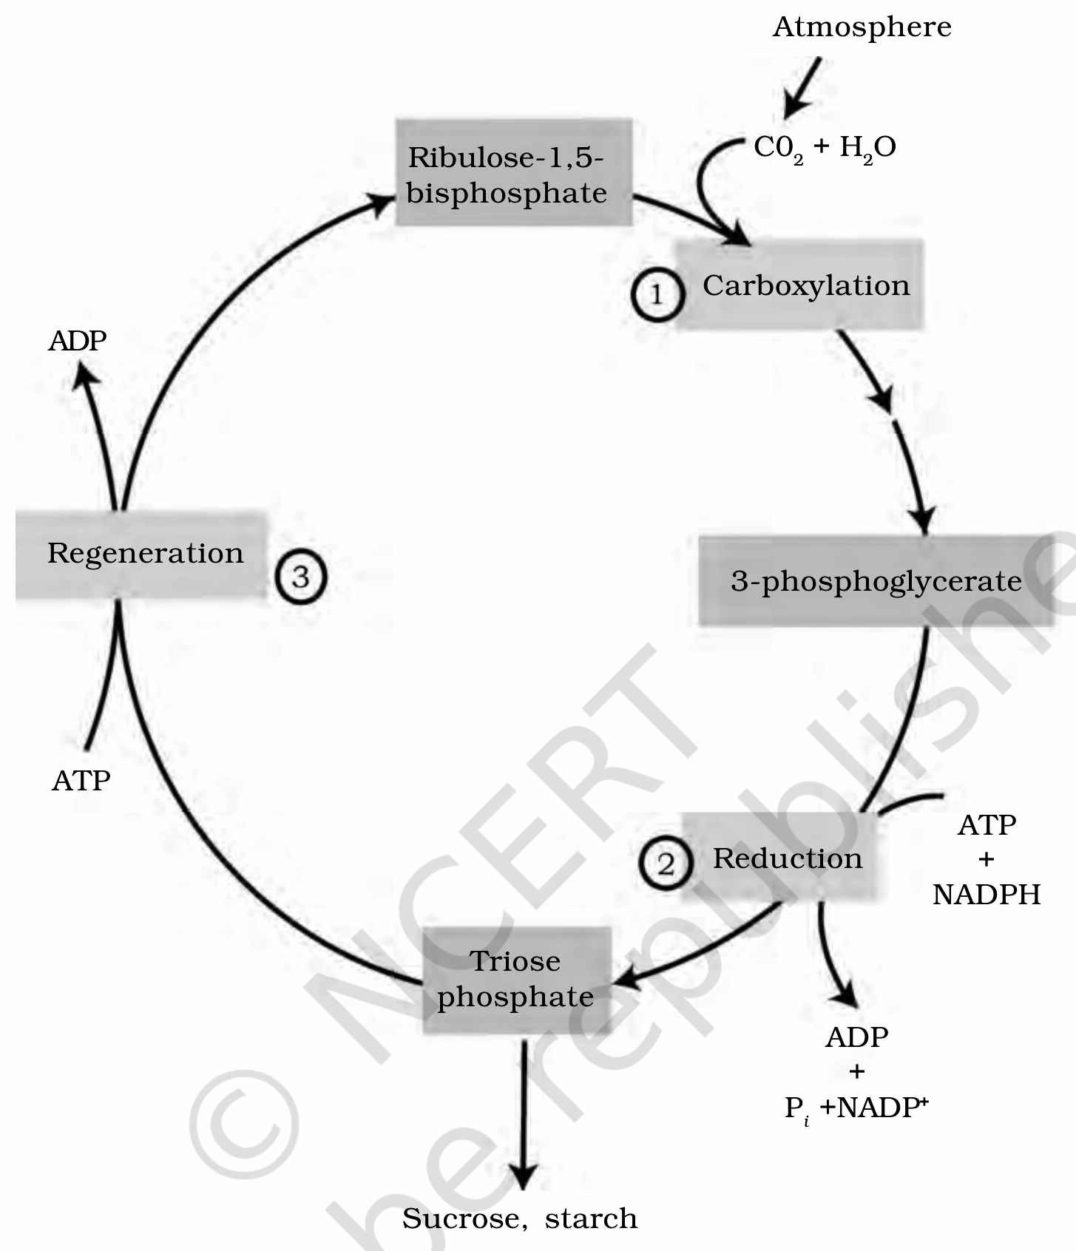
Fig. 11.8 - The Calvin cycle proceeds in three stages: (1) carboxylation, during which CO₂ combines with ribulose-1,5-bisphosphate; (2) reduction, during which carbohydrate is formed at the expense of the photochemically made ATP and NADPH; and (3) regeneration during which the CO₂ acceptor ribulose-1,5-bisphosphate is formed again so that the cycle continues.
The Calvin cycle diagram is marked with CO₂ + H₂O entering from the Atmosphere; the three numbered stages 1, 2 and 3 - Carboxylation, Reduction and Regeneration; the intermediates Ribulose-1,5-bisphosphate, 3-phosphoglycerate and Triose phosphate; the cofactors ATP and ADP on the regeneration step and ATP + NADPH yielding ADP + Pi + NADP⁺ on the reduction step; and the products drawn leaving the cycle as Sucrose, starch.
For ease of understanding, the Calvin cycle can be described under three stages: carboxylation, reduction and regeneration.
Stage 1 | Carboxylation

• Carboxylation is the fixation of CO₂ into a stable organic intermediate. It is the most crucial step of the Calvin cycle, where CO₂ is utilised for the carboxylation of RuBP.
• The reaction is catalysed by the enzyme RuBP carboxylase, which results in the formation of two molecules of 3-PGA.
• RuBisCO - since the RuBP carboxylase enzyme also has an oxygenation activity, it would be more correct to call it RuBP carboxylase-oxygenase, or RuBisCO.
Stage 2 | Reduction

• Reduction is a series of reactions that lead to the formation of glucose. The steps involve utilisation of 2 molecules of ATP for phosphorylation and two of NADPH for reduction, per CO₂ molecule fixed.
• The fixation of six molecules of CO₂ and 6 turns of the cycle are required for the formation of one molecule of glucose from the pathway.
Stage 3 | Regeneration

• Regeneration of the CO₂ acceptor molecule RuBP is crucial if the cycle is to continue uninterrupted. The regeneration steps require one ATP for phosphorylation to form RuBP.
• Hence for every CO₂ molecule entering the Calvin cycle, 3 molecules of ATP and 2 of NADPH are required. It is probably to meet this difference in number of ATP and NADPH used in the dark reaction that the cyclic phosphorylation takes place.
Calvin cycle balance sheet | IN | OUT
Carbon dioxide | six CO₂ | -
Energy carrier | 18 ATP | 18 ADP
Reducing power | 12 NADPH | 12 NADP
Sugar | - | one glucose

[MEMORY AID - not in NCERT] For the Calvin cycle stages, remember C-R-R: Carboxylation, Reduction, Regeneration. And for the per-CO₂ cost, "3 A, 2 N" - 3 ATP and 2 NADPH.

11.8 | THE C₄ PATHWAY

• Plants that are adapted to dry tropical regions have the C₄ pathway. Though C₄ plants have the C₄ oxaloacetic acid as the first CO₂ fixation product, they use the C₃ pathway or the Calvin cycle as the main biosynthetic pathway.
C₄ plants are special - they:
• have a special type of leaf anatomy;
• tolerate higher temperatures;
• show a response to high light intensities;
• lack a process called photorespiration;
• have greater productivity of biomass.
• Bundle sheath cells - the particularly large cells around the vascular bundles of the C₄ plants. Leaves which have such anatomy are said to have 'Kranz' anatomy. 'Kranz' means 'wreath' and is a reflection of the arrangement of cells.
The bundle sheath cells may form several layers around the vascular bundles. They are characterised by having:
- a large number of chloroplasts;
- thick walls impervious to gaseous exchange;
- no intercellular spaces.
• Maize and sorghum are C₄ plants whose leaves may be sectioned to observe the Kranz anatomy and the distribution of mesophyll cells. The presence of the bundle sheath around the vascular bundles would help you identify the C₄ plants.
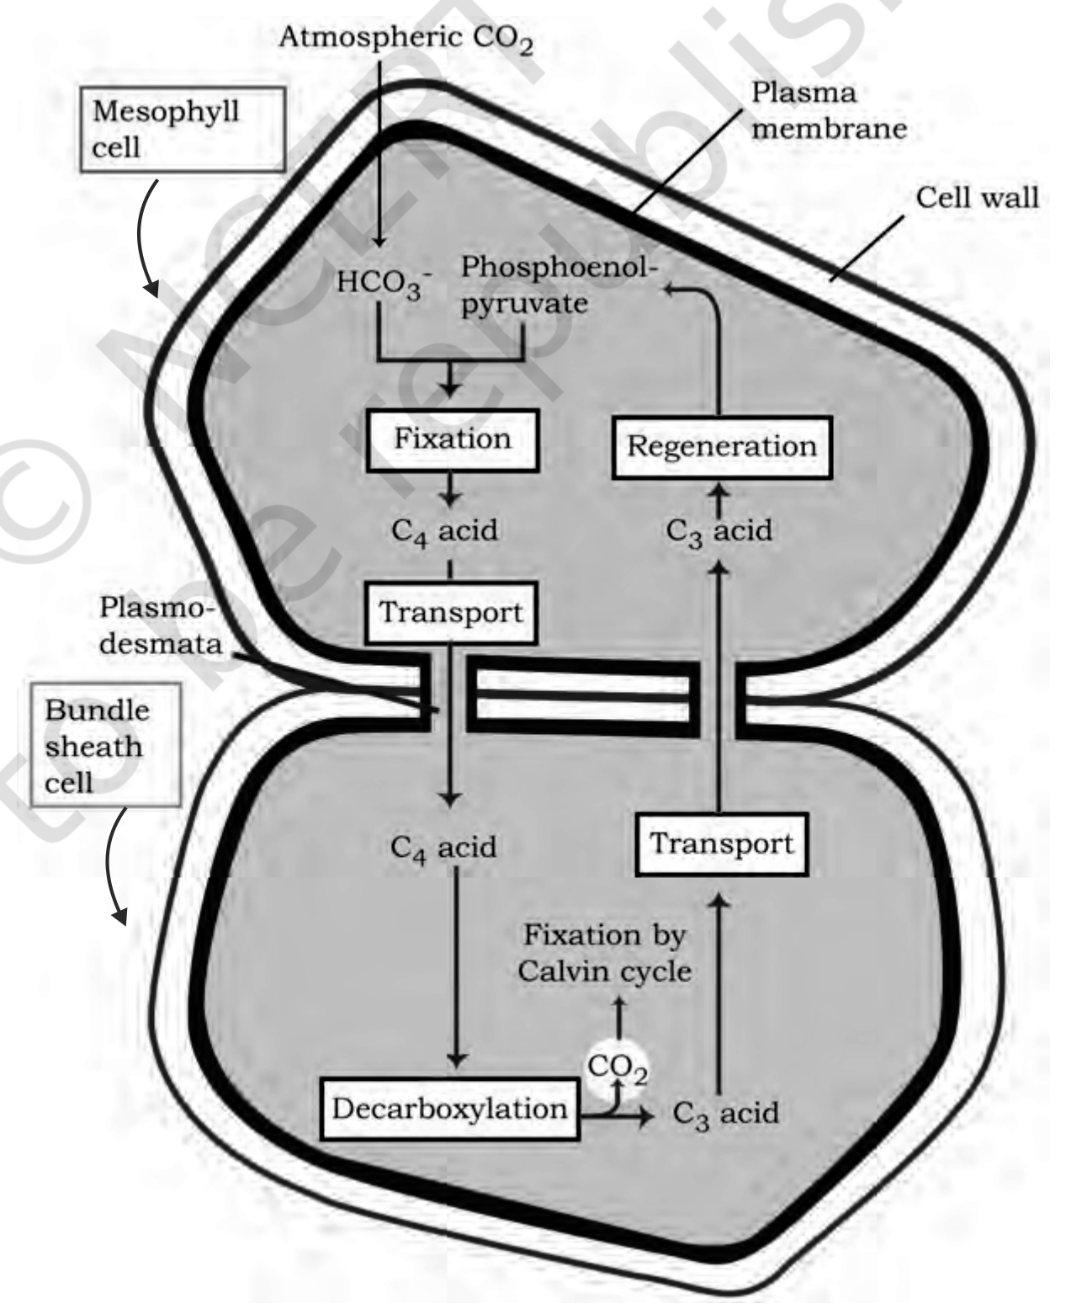
Fig. 11.9 - Diagrammatic representation of the Hatch and Slack Pathway.
The Hatch and Slack Pathway diagram is drawn across two cells. In the Mesophyll cell, bounded by its Cell wall and Plasma membrane, Atmospheric CO₂ enters as HCO₃⁻ and undergoes Fixation with Phosphoenol-pyruvate to give a C₄ acid. The C₄ acid undergoes Transport through the Plasmodesmata into the Bundle sheath cell, where Decarboxylation releases CO₂ for Fixation by Calvin cycle, and the C₃ acid returns to the mesophyll cell for Regeneration of phosphoenol-pyruvate.
• The C₄ pathway shown in Figure 11.9 has been named the Hatch and Slack Pathway, and is again a cyclic process.
• The primary CO₂ acceptor is a 3-carbon molecule phosphoenol pyruvate (PEP) and is present in the mesophyll cells. The enzyme responsible for the primary CO₂ fixation in C₄ plants is PEP carboxylase or PEPcase.
[NOTE] It is important to register that the mesophyll cells lack RuBisCO enzyme.

1 | (cycle - last step feeds back to step 1)
2 | The C₄ acid OAA is formed in the mesophyll cells.
3 | OAA then forms other 4-carbon compounds like malic acid or aspartic acid in the mesophyll cells itself, which are transported to the bundle sheath cells.
4 | In the bundle sheath cells these C₄ acids are broken down to release CO₂ and a 3-carbon molecule.
5 | The 3-carbon molecule is transported back to the mesophyll, where it is converted to PEP again, thus completing the cycle.
6 | The CO₂ released in the bundle sheath cells enters the C₃ or the Calvin pathway, a pathway common to all plants.

• The bundle sheath cells are rich in an enzyme Ribulose bisphosphate carboxylase-oxygenase (RuBisCO), but lack PEPcase.
• Thus the basic pathway that results in the formation of the sugars, the Calvin pathway, is common to the C₃ and C₄ plants. It occurs in all the mesophyll cells of the C₃ plants; in the C₄ plants it does not take place in the mesophyll cells but does so only in the bundle sheath cells.
Kranz anatomy is an internal criterion. Whether a plant can be told apart as C₃ or C₄ by looking at it externally is answered in the closing section, 'Terms used in the exercises'.
11.9 | PHOTORESPIRATION

Photorespiration is one more process that creates an important difference between C₃ and C₄ plants.
• The first CO₂ fixation step of the Calvin pathway is the reaction where RuBP combines with CO₂ to form 2 molecules of 3PGA, catalysed by RuBisCO: RuBP + CO₂, catalysed by RuBisCO, yields 2 x 3PGA.
• RuBisCO is the most abundant enzyme in the world. It is characterised by the fact that its active site can bind to both CO₂ and O₂ - hence the name.
• RuBisCO has a much greater affinity for CO₂ when the CO₂:O₂ is nearly equal. The binding of CO₂ and O₂ to RuBisCO is competitive, and it is the relative concentration of O₂ and CO₂ that determines which of the two will bind to the enzyme.
• In C₃ plants some O₂ does bind to RuBisCO, and hence CO₂ fixation is decreased.
• Photorespiration - here the RuBP, instead of being converted to 2 molecules of PGA, binds with O₂ to form one molecule of phosphoglycerate and phosphoglycolate (2 Carbon).
• In the photorespiratory pathway there is neither synthesis of sugars nor of ATP; rather it results in the release of CO₂ with the utilisation of ATP. There is no synthesis of ATP or NADPH.
[NOTE] The biological function of photorespiration is not known yet.

• RuBisCO also catalyses a wasteful oxygenation reaction in C₃ plants: photorespiration.
• In C₄ plants photorespiration does not occur, because they have a mechanism that increases the concentration of CO₂ at the enzyme site.
• This takes place when the C₄ acid from the mesophyll is broken down in the bundle sheath cells to release CO₂, which results in increasing the intracellular concentration of CO₂. In turn this ensures that the RuBisCO functions as a carboxylase, minimising the oxygenase activity.
• Since the C₄ plants lack photorespiration, productivity and yields are better in these plants. In addition, these plants show tolerance to higher temperatures.
Table 11.1 | DIFFERENCES BETWEEN C₃ AND C₄ PLANTS

NCERT prints TABLE 11.1 with Columns 2 and 3 left blank, to be filled in to highlight the differences between C₃ and C₄ Plants. The completed table, filled from this chapter's own statements, is:
Characteristic | C₃ plants | C₄ plants
Cell type in which the Calvin cycle takes place | Mesophyll | Bundle sheath
Cell type in which the initial carboxylation reaction occurs | Mesophyll | Mesophyll
How many cell types the leaf has that fix CO₂ | One: Mesophyll | Two: Bundle sheath and mesophyll
Which is the primary CO₂ acceptor | RuBP | PEP
Number of carbons in the primary CO₂ acceptor | 5 | 3
Which is the primary CO₂ fixation product | PGA | OAA
Number of carbons in the primary CO₂ fixation product | 3 | 4
Does the plant have RuBisCO | Yes | Yes
Does the plant have PEP Case | No | Yes
Which cells in the plant have RuBisCO | Mesophyll | Bundle sheath
CO₂ fixation rate under high light conditions | Low | High
Is photorespiration present at low light intensities | Negligible | Negligible
Is photorespiration present at high light intensities | High | Negligible
Would photorespiration be present at low CO₂ concentrations | High | Negligible
Would photorespiration be present at high CO₂ concentrations | Negligible | Negligible
Temperature optimum | 20-25 degrees C | 30-40 degrees C
Examples | Tomatoes, bell pepper | Maize, sorghum

The 'Choose from' options NCERT supplies with the table are: Mesophyll / Bundle sheath / both; Two: Bundle sheath and mesophyll, One: Mesophyll, Three: Bundle sheath, palisade, spongy mesophyll; RuBP / PEP / PGA; 5 / 4 / 3; PGA / OAA / RuBP / PEP; 3 / 4 / 5; Yes / No / Not always; Mesophyll / Bundle sheath / none; Low / high / medium; High / negligible / sometimes; and 30-40 degrees C / 20-25 degrees C / above 40 degrees C.
11.10 | FACTORS AFFECTING PHOTOSYNTHESIS

An understanding of the factors that affect photosynthesis is necessary, because the rate of photosynthesis is very important in determining the yield of plants, including crop plants.
Photosynthesis is under the influence of several factors, both internal (plant) and external:
Factor group | Factors it includes
Plant (internal) factors | The number, size, age and orientation of leaves, mesophyll cells and chloroplasts, internal CO₂ concentration, and the amount of chlorophyll. These are dependent on the genetic predisposition and the growth of the plant.
External factors | The availability of sunlight, temperature, CO₂ concentration and water.

• As a plant photosynthesises, all these factors will simultaneously affect its rate. Hence, though several factors interact and simultaneously affect photosynthesis or CO₂ fixation, usually one factor is the major cause or is the one that limits the rate. Hence at any point the rate will be determined by the factor available at sub-optimal levels.
• Blackman's (1905) Law of Limiting Factors - comes into effect when several factors affect any [bio] chemical process. It states: if a chemical process is affected by more than one factor, then its rate will be determined by the factor which is nearest to its minimal value; it is the factor which directly affects the process if its quantity is changed.
• For example, despite the presence of a green leaf and optimal light and CO₂ conditions, the plant may not photosynthesise if the temperature is very low. This leaf, if given the optimal temperature, will start photosynthesising.
11.10.1 | Light

We need to distinguish between light quality, light intensity and the duration of exposure to light, while discussing light as a factor that affects photosynthesis.
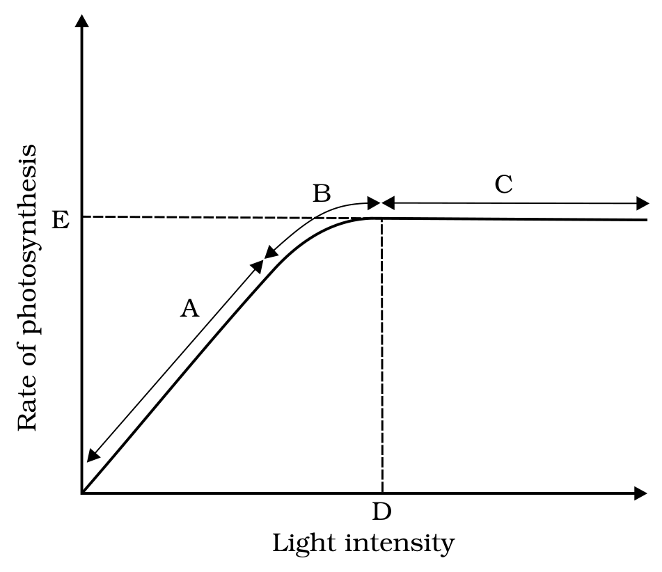
Fig. 11.10 - Graph of light intensity on the rate of photosynthesis.
The graph's vertical axis is the Rate of photosynthesis and its horizontal axis is Light intensity. The points A, B, C, D and E are marked along the curve.
• There is a linear relationship between incident light and CO₂ fixation rates at low light intensities.
• At higher light intensities, gradually the rate does not show further increase as other factors become limiting.
• Light saturation occurs at 10 per cent of the full sunlight. Hence, except for plants in shade or in dense forests, light is rarely a limiting factor in nature.
• Increase in incident light beyond a point causes the breakdown of chlorophyll and a decrease in photosynthesis.
11.10.2 | Carbon dioxide Concentration

• Carbon dioxide is the major limiting factor for photosynthesis. The concentration of CO₂ is very low in the atmosphere (between 0.03 and 0.04 per cent).
• Increase in CO₂ concentration upto 0.05 per cent can cause an increase in CO₂ fixation rates; beyond this the levels can become damaging over longer periods.
• The C₃ and C₄ plants respond differently to CO₂ concentrations, and at low light conditions neither group responds to high CO₂ conditions. At high light intensities both C₃ and C₄ plants show increase in the rates of photosynthesis.
Plant group | Response to increased CO₂ concentration
C₄ plants | Show saturation at about 360 microlitre per litre
C₃ plants | Respond to increased CO₂ concentration; saturation is seen only beyond 450 microlitre per litre

• Thus, current availability of CO₂ levels is limiting to the C₃ plants.
• The fact that C₃ plants respond to higher CO₂ concentration by showing increased rates of photosynthesis leading to higher productivity has been used for some greenhouse crops such as tomatoes and bell pepper, which are allowed to grow in a carbon dioxide enriched atmosphere that leads to higher yields.
11.10.3 | Temperature

• The dark reactions being enzymatic are temperature controlled. Though the light reactions are also temperature sensitive, they are affected to a much lesser extent.
• The C₄ plants respond to higher temperatures and show a higher rate of photosynthesis, while C₃ plants have a much lower temperature optimum.
• The temperature optimum for photosynthesis of different plants also depends on the habitat that they are adapted to: tropical plants have a higher temperature optimum than the plants adapted to temperate climates.
11.10.4 | Water

• Even though water is one of the reactants in the light reaction, the effect of water as a factor is more through its effect on the plant, rather than directly on photosynthesis.
• Water stress causes the stomata to close, hence reducing the CO₂ availability.
• Besides, water stress also makes leaves wilt, thus reducing the surface area of the leaves and their metabolic activity as well.
Recap | QUICK RECAP

• Green plants are autotrophs - they make their own food by photosynthesis, a physico-chemical process using light energy to synthesise organic compounds. CO₂ is taken in through stomata and used to make carbohydrates, principally glucose and starch.
• Photosynthesis occurs only in the green parts, mainly the leaves, whose mesophyll cells carry many chloroplasts. In the chloroplast, the membranes run the light reaction and the stroma runs the chemosynthetic (carbon-fixing) pathway - the two stages of photosynthesis.
• Four pigments separate on a chromatogram: chlorophyll a (the chief pigment), chlorophyll b, xanthophylls and carotenoids; the last three are accessory pigments, which widen the usable wavelength range and protect chlorophyll a from photo-oxidation. Most photosynthesis happens in the blue and red regions.
• Light energy absorbed by the antenna pigments is funnelled to the reaction centre chlorophylls. PS I has P700, PS II has P680. Electrons run PS II to PS I to NADP⁺ along the Z scheme, giving NADPH; splitting of water at PS II supplies the replacement electrons and releases O₂ and protons.
• Non-cyclic photophosphorylation (PS II then PS I) makes ATP and NADPH; cyclic photophosphorylation (PS I alone, in the stroma lamellae, which lack PS II and NADP reductase) makes only ATP. ATP synthesis is chemiosmotic: protons accumulate in the thylakoid lumen, and their return through CF₀ drives a conformational change in CF₁ of ATP synthase.
• In the carbon fixation cycle, RuBisCO adds CO₂ to the 5-carbon RuBP, giving 2 molecules of 3-carbon PGA. The Calvin cycle - carboxylation, reduction, regeneration - converts this to sugar and regenerates RuBP, at 3 ATP and 2 NADPH per CO₂, so 6 CO₂, 18 ATP and 12 NADPH yield one glucose.
• RuBisCO also catalyses a wasteful oxygenation reaction in C₃ plants - photorespiration - which makes no sugar, no ATP and no NADPH, and whose biological function is not known yet.
• Some tropical plants use the C₄ pathway. PEPcase fixes CO₂ in the mesophyll to the 4-carbon OAA; C₄ acids move to the bundle sheath cells ('Kranz' anatomy), where decarboxylation concentrates CO₂ and the Calvin pathway makes the carbohydrate. This abolishes photorespiration and gives higher productivity and tolerance of higher temperatures.
• Rate-limiting factors follow Blackman's Law of Limiting Factors. Light saturates at 10 per cent of full sunlight; CO₂ (0.03-0.04 per cent in air) is the major limiting factor; dark reactions are temperature controlled; and water acts indirectly, by closing stomata and wilting leaves.
Appendix | TERMS USED IN THE EXERCISES

Four of the chapter's questions lean on something the chapter never states outright. Those four are reproduced here with their answers. The answers marked [addition] go beyond what this chapter states.
Ex. 1 | By looking at a plant externally, can you tell whether a plant is C₃ or C₄? Why and how?

No. [addition] C₃ and C₄ plants cannot be distinguished by external appearance. Every criterion this chapter gives is internal: the 'Kranz' anatomy - the large bundle sheath cells around the vascular bundles, with many chloroplasts, thick walls impervious to gaseous exchange and no intercellular spaces - which is visible only in a section of the leaf, not from the outside.
Ex. 5 | Suppose there were plants that had a high concentration of Chlorophyll b, but lacked chlorophyll a, would it carry out photosynthesis? Then why do plants have chlorophyll b and other accessory pigments?

No, it would not. [addition] Chlorophyll a is indispensable: this chapter states that chlorophyll a is the chief pigment associated with photosynthesis, and that the single chlorophyll a molecule forms the reaction centre of each photosystem. A plant with only chlorophyll b would have no reaction centre, so the light energy it absorbed could not be converted. Chlorophyll b, xanthophylls and carotenoids are accessory pigments: they absorb light and transfer the energy to chlorophyll a, which both widens the range of wavelengths usable for photosynthesis and protects chlorophyll a from photo-oxidation.
Ex. 6 | Why is the colour of a leaf kept in the dark frequently becomes yellow, or pale green? Which pigment do you think is more stable?

[addition] A leaf kept in the dark turns yellow or pale green because chlorophyll breaks down faster in the dark than the carotenoids do. As the green chlorophyll is lost, the yellow accessory pigments - the xanthophylls and carotenoids - are left behind and their colour shows through. The more stable pigments are therefore the carotenoids (and xanthophylls); chlorophyll is the less stable. This chapter states that the accessory pigments protect chlorophyll a from photo-oxidation, but it does not give this dark-degradation ordering.
Ex. 7 | Look at leaves of the same plant on the shady side and compare it with the leaves on the sunny side. Or, compare the potted plants kept in the sunlight with those in the shade. Which of them has leaves that are darker green? Why?

The leaves on the shady side - and the potted plants kept in the shade - have the darker green leaves. [addition] A shade leaf builds more chlorophyll per unit leaf area, so that it can trap as much as possible of the little light it receives; the extra chlorophyll is what makes it look darker green. This chapter states only that light is rarely a limiting factor in nature except for plants in shade or in dense forests, and that increase in incident light beyond a point causes the breakdown of chlorophyll - so the sunny-side leaf keeps less chlorophyll.
Note | A Note on the PS II / PS I Electron Replacement Wording

[NOTE] True fact: the electron flow through the light reaction is one continuous, non-cyclic chain - water -> PS II -> PS I -> NADP⁺. Water splitting at PS II is the ultimate source of every electron in the chain, so it is water's electrons that end up replacing what PS I loses, using PS II purely as the relay in between.

[NOTE] As NCERT itself states it (Ch.11, SS11.6.1, verbatim): "The electrons that were moved from photosystem II must be replaced. This is achieved by electrons available due to splitting of water... The electrons needed to replace those removed from photosystem I are provided by photosystem II." NCERT describes this as two separate replacement steps - water replaces PS II's electrons, then PS II replaces PS I's electrons - rather than as one continuous chain, which is why a first read can suggest PS II's electrons are being replaced twice. This is a known quirk of NCERT's own phrasing, carried here exactly as printed, not an error introduced in these notes.

